Possible attacks on existing security hub architecture –
© Suhas Aggarwal (suhas@iitg.ernet.in)

Both of the attacks described here,exploit TLS protocol to launch a DOS attack.

1) TCP data injection -
While TLS itself may be as secure as possible, the use of TCP without additional cross-layer functionality makes it almost impossible to protect TLS against Denial-of-Service (DoS) attacks on the TCP layer.
For, TLS the injection of just any data denotes a DoS attack. TCP assembles IP packets into a data stream and hands this stream over to TLS. In the effort of suppressing duplicate packets it hands over a given range of bytes just once.
If an attacker is able to inject an arbitrary amount of random bytes into the byte stream TCP hands over to TLS, the data integrity check of TLS will fail, and the data has to be dropped. This behavior combined with TCP’s dropping of duplicate packets leads to the TLS layer needing data that the TCP layer believes to have already handed over, and therefore detects as duplicates. A TLS implementation needs to restart the complete TLS connection in such a case.

2)Forcing the TLS server to perform large number of illegitimate RSA decryptions-
An attacker attempts to incapacitate a TLS server by initiating large no. of TLS handshake requests per second as the number of RSA decryptions the server can perform per second. A high end server can process upto 4000 RSA decryptions per second.
If we assume that a partial TLS handshake takes 200 bytes, then 800 KB/s is sufficient to paralyze the server.

Solutions -

1)Adding authentication at the TCP layer -
The major problem of TLS is TCP offers a reliable service and delivers data to the upper layer protocols just once because it is supposed to suppress duplicates. TCP’s decision is based on the unsecured entries of the TCP header, or else it could find out that the received packet is a forgery. Even if TLS could figure out that a given data segment was injected, TCP would not pass TLS the original data since it seems to be duplicate.
Solution is to add authentication at the TCP layer using TCP MD5 option.

Authentication is achieved by combining advantages of TLS and TCP MD5 option.
TLS allows to setup a secure connection to an unknown peer, (though peers, ehosts and ihosts may not be unknown in this scenario) but misses authentication of data below the TLS layer. The MD5 option adds the missing data authentication but cannot set up connections with unknown peers.Two approaches can be combined start TLS without protection first and use it to set up the MD5 option for the TLS connection as soon as possible.

Protocol description-

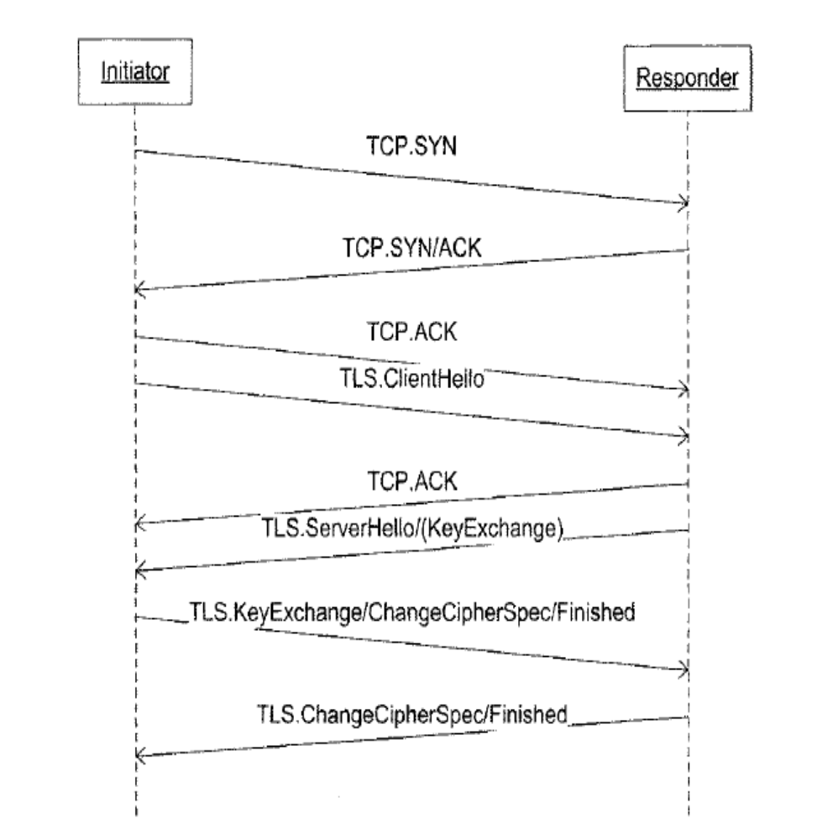

So, the time during which an attack is possible is reduced to the first packets, namely
the TCP three way handshake and the first phase of the TLS key exchange.
After the TLS handshake phase, the attacker would not be able to successfully inject packets into the TCP. Therefore, the TLS connection is secure for the rest of its lifetime

Considering Network Address Translation-
The original TCP MD5 option authenticates TCP’s data and header, as well as the IP source address. If a NAT modifies the packet in transit the IP source address in the
packet will be changed, and the receiver’s integrity check with the TCP MD5 option
will fail.
But as sender is already authenticated as an entity using TLS mechanisms, authenticating the IP address is not a requirement.

2) Client puzzle solution -
The idea of client puzzles is to slow down the attacker sufficiently that a denial of service
is no longer possible.
In order to prevent the denial-of-service attack against TLS, a new message is added after the Server Hello message and before the Server Done message. This message contains a cryptographic puzzle and is only sent when the server is under load. The server will then wait on a response message before continuing with the handshake protocol.
The type of client puzzle used consists of inverting a hash function when given the hash digest and a certain portion of the pre-image. After the client has sent its client hello message, the server chooses a random a-bit value s and inputs it to a cryptographic hash function. It then includes the hash digest t = hash(s) along with the b first bits of s
(where b < a) to the client in the server hello message. Using these b bits, the client solves the client puzzle via brute-force and finds a value s' that hashes to the desired t. With knowledge of the first b pre-image bits, the client only needs to attempt approximately 2 candidate values before finding a valid solution s' that satisfies t = hash(s').The client then includes s' in its client key exchange message.
Only if s' verifies - i.e, it is of correct length and its hash output is t - will the server proceed with the SSL handshake and decrypt the encrypted session key submitted by
the client.
The computational cost of a hash computation is almost negligible when compared to an RSA decryption (a hash is about 3 to 4 orders of magnitude faster to compute), so
the addition of puzzle verification step adds a very minor server side overhead. The amount of work needed to be done by the client in order to solve the puzzle depends upon
its computing resources and, more importantly, the number of unknown bits in the pre-image value sent by the server.
The addition of client puzzles to the SSL handshake protocol has the advantage of making DoS attacks more elaborate to carry out. A single client machine is no longer able
to easily overload an SSL server by sending consecutive SSL initiation requests, as it would need to solve the appropriate client puzzles, thereby limiting the number of valid requests it could send per second.

3)CLIENT AIDED RSA -

The main idea is to shift some computational burden from the ihosts to the ehosts. Specifically,clients should perform the bulk of the work in RSA decryption, thereby allowing the server to accept and process more incoming requests.

Computation transfer-
We begin by representing the server’s private exponent as d = f₁d₁ + f₂d₂ + ... + f_{k} d_{k} (mod φ(n)), where the f_{i} ’s and d_{i}’s are random vector elements of c and |n| bits, respectively.

The following processes take place when a server wants to offload the computation
x^{d} (mod n) to a client:
1. Server sends vector D = (d₁ , d₂, ..., d_{k} ) to client.
2. Client computes vector Z = (z₁, z₂ , ..., z_{k}), where z_{i} =x^{di} (mod n), and sends it back to server.
3. Finally, server computes
∏_{i=1} ^{k} z_{i}^{fi} _{= ∏i=1} ^{k} x^{fidi} = x^{d} (mod n)

Note that, assuming that it is computationally difficult to “break” RSA, parameter selection should not introduce any attacks that compromise the security of the above computation by the server, namely x^{d} (mod n). An attacker can attempt to exhaust all possible vector values fi thereby deriving d. Thus, a minimal requirement for c and k is that a brute force attack (which requires 2^{c×k} steps) should be as difficult as breaking underlying RSA.

The client hello and server hello messages remain unchanged, although the server’s certificate (which is sent as part of the server hello message) now includes the vector D = (d₁, d₂, ..., d_{k} ). The client chooses a random value x, which is then used to derive the TLS session key, and uses the server’s public exponent to encrypt it: y = x^{e} (mod n). Next, the client uses D to construct a vector Z by computing the individual vector elements z_{i} = y^{di} (mod n), for 1 ≤ i ≤ k. This vector is included in the client key exchange message. The server, upon receiving this message and derives y^{d} = (x^{e})^{d} = x (mod n).

Note:
Chinese remainder theorem can be used to speed up RSA secret key exponentiations.

MODIFICATIONS TO EXISTING IEC 61850 PROTOCOL STACK -

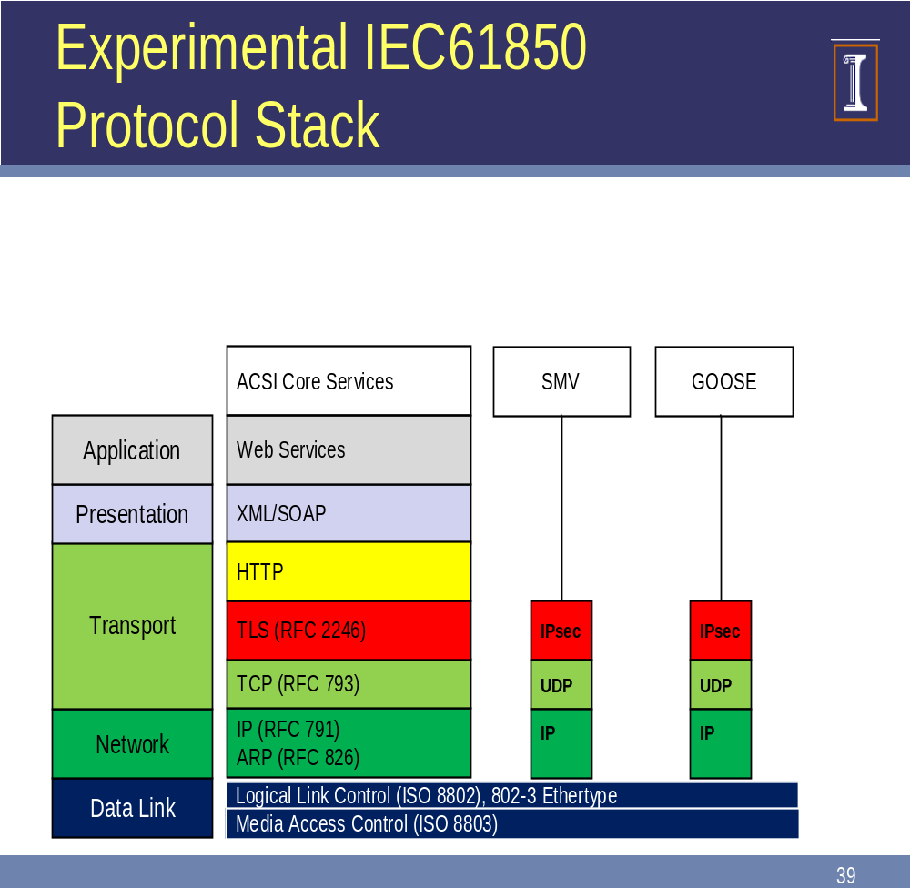

Existing IEC 61850 protocol stack.

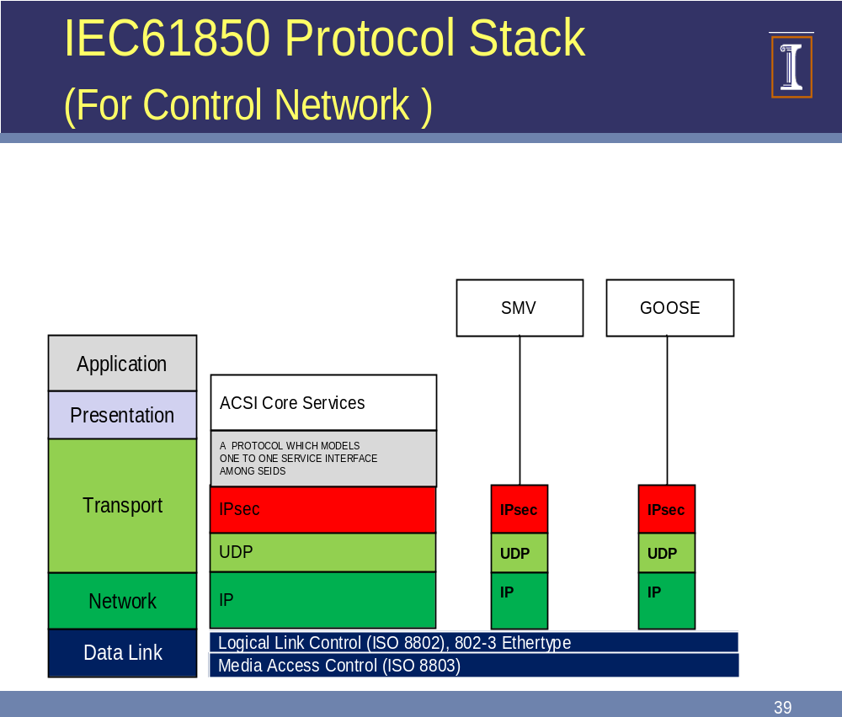

A New Component added to protocol stack, to meet one to one communication need among SIEDS.

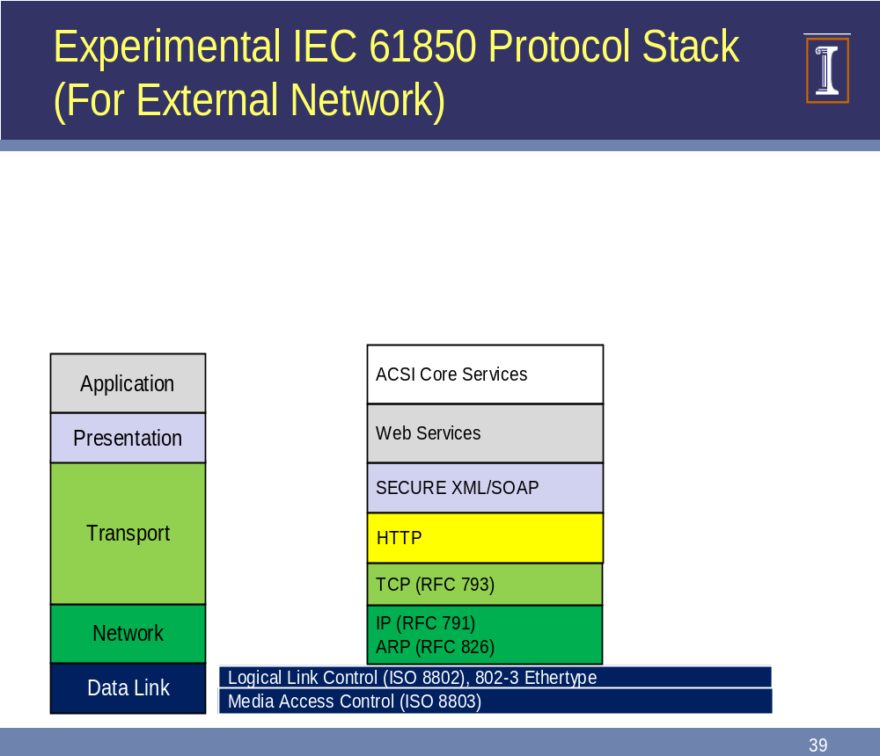

How XML security will work in this scenario and suits the needs of the architecture?

As information between ihosts and ehosts is exchanged in XML format, security can be embedded in the document itself, eliminating the need of TLS.

XML document being sent to the ihost is digitally signed by the respective ehost.
ihost on receiving the document verifies the digital signature of ehost .
Respective public keys of ehosts can be obtained easily in a secure manner by utilizing DNSSEC architecture .

Some possible benefits as compared to TLS-

Suppose,an XML document say a substation configuration file is to be transferred whose contents are filled by some specific ehosts i.e there are different authentication requirements for different sections of a document.
On using TLS, each ehost will establish a separate TLS connection with the ihost in the control network and send the required information.
On using XML security options,it can be easily accomplished by using digital signatures.Each ehost will sign its section in the document and this document will be propagated to the control network.On receiving the document, ihost can easily verify,individual signatures.
Also,it will be possible to encrypt specific sections of document.

SOAP accounts should be included in the soap messages to provide protection against XML rewriting attacks.

